**AWS Dashboard Creation**

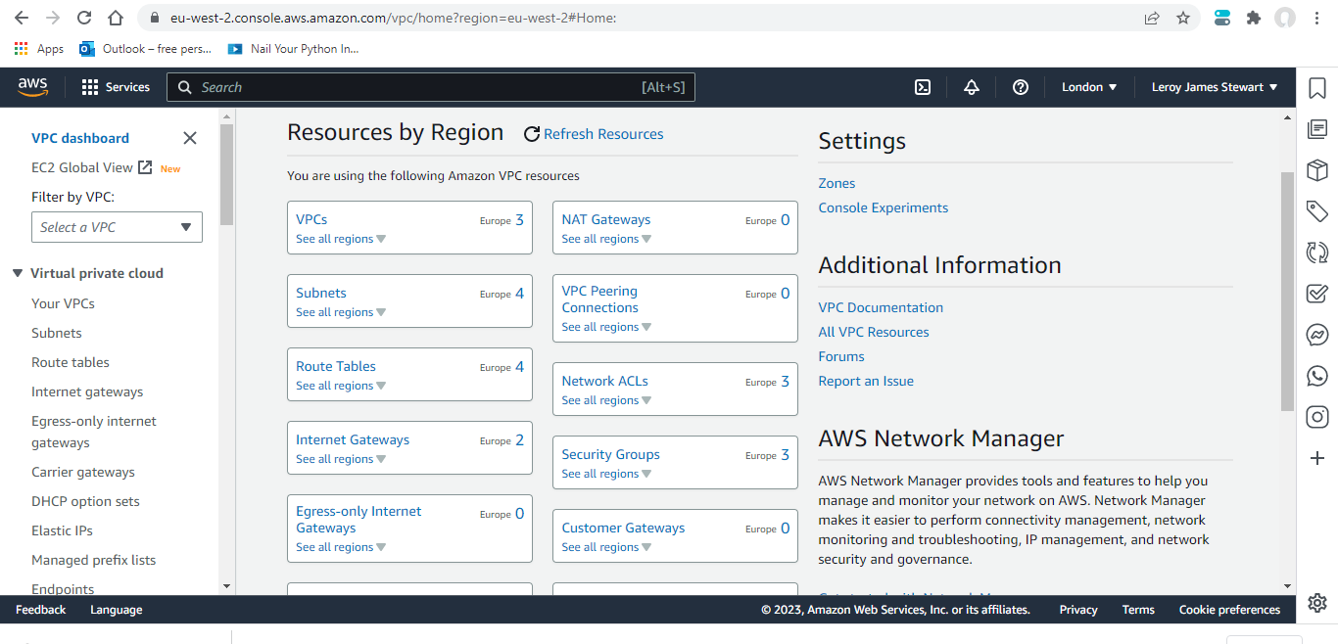

This Dashboard is a combination of the Sub-net and VPC configuration and this type of visual would enable ‘Data Migration’ from other regions of the world. However, this type allows to upload substantial amounts of ‘Data’ with sufficient Security, Observability, Elasticity and many more features and tools.